Huawei centreon Plug-in

User Guide
 | Issue | 01
 | Date | 2018-08-17

About This Document
Overview
This document describes how to install and uninstall the Huawei centreon plug-in, view server health status, and receive SNMP trap alarms.
Intended Audience
This document is intended for:
- Technical support engineers
- Maintenance engineers
Symbol Conventions
The symbols that may be found in this document are defined as follows.
Symbol | Description
 | Indicates an imminently hazardous situation which, if not avoided, will result in death or serious injury.
 | Indicates a potentially hazardous situation which, if not avoided, could result in death or serious injury.
 | Indicates a potentially hazardous situation which, if not avoided, could result in minor or moderate injury.
 | Indicates a potentially hazardous situation which, if not avoided, could result in equipment damage, data loss, performance deterioration, or unanticipated results.  NOTICE is used to address practices not related to personal injury.
Calls attention to important information, best practices, and tips.
NOTE is used to address information not related to personal injury, equipment damage, and environment deterioration.

Change History
Changes between document issues are cumulative. The latest document issue contains all the changes made in earlier issues.
Issue 01 (2018-08-17)
This issue is the first official release.
Contents
About This Document ii
1 Introduction 1
2 Using centreon (Version 3.4.6) 3
2.1 Monitoring the Server Health Status 3
2.1.1 Installing and Uninstalling the Huawei centreon Plug-in 3
2.1.1.1 Installing the centreon Plug-in 3
2.1.1.2 Uninstalling the centreon Plug-in 4
2.1.2 Configuring the Server Health Status Monitoring Function 4
2.1.2.1 Configuring a Command 4
2.1.2.2 Configuring a Host 8
2.1.2.3 Configuring a Service 10
2.1.2.4 Generating a Configuration File and Making the ConfigurationTake Effect 11
2.1.3 Viewing the Server Status 12
2.2 Receiving Server SNMP Alarms 12
2.2.1 Configuring Server Trap Parameters 13
2.2.1.1 Configuring a Rack/High-Density Server 13
2.2.1.2 Configuring a Blade Server 13
2.2.2 Receiving SNMPv2c Alarms 14
2.2.2.1 Importing the MIB File 14
2.2.2.2 Configuring a Receiving Host 16
2.2.2.3 Creating a Service and Associating it with a Host and a Trap 18
2.2.2.4 Generating a Configuration File and Making the ConfigurationTake Effect 20
2.2.2.5 Receiving Alarms 21
2.2.3 Receiving SNMPv3 Alarms 21
2.2.3.1 Obtaining the Engine ID 21
2.2.3.2 Configuring the Authentication User Information 23
2.2.3.3 Configuring a Receiving Host 26
2.2.3.4 Creating a Service and Associating it with a Host and a Trap 27
2.2.3.5 Generating a Configuration File and Making the ConfigurationTake Effect 29
2.2.3.6 Receiving Alarms 30
3 Using centreon (Version 2.3.8) 31
3.1 Monitoring the Server Health Status 31
3.1.1 Installing and Uninstalling the Huawei centreon Plug-in 31
3.1.1.1 Installing the centreon Plug-in 31
3.1.1.2 Uninstalling the centreon Plug-in 32
3.1.2 Configuring the Server Health Status Monitoring Function 32
3.1.2.1 Configuring a Command 32
3.1.2.2 Configuring a Host 36
3.1.2.3 Configuring a Service 38
3.1.2.4 Generating a Configuration File and Making the ConfigurationTake Effect 40
3.1.3 Viewing the Server Status 41
3.2 Receiving Server SNMP Alarms 41
3.2.1 Configuring Server Trap Parameters 41
3.2.1.1 Configuring a Rack/High-Density Server 41
3.2.1.2 Configuring a Blade Server 42
3.2.2 Receiving SNMPv2c Alarms 43
3.2.2.1 Importing the MIB File 43
3.2.2.2 Configuring a Receiving Host 45
3.2.2.3 Creating a Service and Associating it with a Host and a Trap 46
3.2.2.4 Generating a Configuration File and Making the ConfigurationTake Effect 49
3.2.2.5 Receiving Alarms 49
3.2.3 Receiving SNMPv3 Alarms 50
3.2.3.1 Obtaining the Engine ID 50
3.2.3.2 Configuring the Authentication User Information 51
3.2.3.3 Configuring a Receiving Host 54
3.2.3.4 Creating a Service and Associating it with a Host and a Trap 55
3.2.3.5 Generating a Configuration File and Making the ConfigurationTake Effect 58
3.2.3.6 Receiving Alarms 58

Introduction
The Huawei centreon plug-in is a plug-in integrated on the centreon platform. The plug-in uses SNMP to connect to the iBMC or HMM to monitor Huawei servers.
You can implement the following functions by using this plug-in:
- Use SNMPv1, SNMPv2c, and SNMPv3 to view the health status of servers and components.
- Receive SNMPv2c and SNMPv3 trap alarms of all server components.
The Huawei centreon plug-in supports the following servers and components:
- Table 1-1 lists the servers supported by the Huawei centreon plug-in.
- Table 1-2 lists the components that support the health check function of the Huawei centreon plug-in.
                - Supported servers
Type | Server
Rack server | RH2288H V2
Rack server | RH1288 V3
Rack server | RH2288 V3
Rack server | RH2288H V3
Rack server | RH5288 V3
Rack server | RH8100 V3
Rack server | 1288H V5
Rack server | 2288H V5
Rack server | 2488 V5
High-density server | XH321 V3
High-density server | XH620 V3
High-density server | XH622 V3
High-density server | XH628 V3
High-density server | XH321 V5
Blade server | E9000

                - Supported components
Server Type | Component
Rack/high-density server | CPU, PSU/power consumption, fan, memory, RAID controller card, drive, and system health status
Blade server | PSU/power consumption, fan, SMM, chassis, switch module, and compute node status, compute node CPU, memory, drive, RAID controller card, and mezzanine card

Using centreon (Version 3.4.6)
In this chapter, centreon 3.4.6 and centreon Web 2.8.22 are used.
2.1 Monitoring the Server Health Status
2.2 Receiving Server SNMP Alarms

Monitoring the Server Health Status

Installing and Uninstalling the Huawei centreon Plug-in

Installing the centreon Plug-in
            - Use the SSH mode (such as PuTTY) to log in to the centreon server.
            - Run the following commands to install the official centreon plug-in:
# yum install git
# git clone https://github.com/centreon/centreon-plugins.git
            - Copy the centreon-plugins folder from the current directory to the installation directory, for example, /usr/local/.
            - Install the plug-in extension package that supports Huawei servers.
- Run the following command to switch to the centreon server directory:
cd /tmp
- Run the following command to install the Huawei centreon plug-in software package:
#git clone https://github.com/Huawei/Server_Management_Plugin_Centreon.git
- Go to the /Server_Management_Plugin_Centreon/releases directory and run the following command to decompress the Huawei centreon plug-in software package:
tar -xzvf centreonPluginForHuaweiServer_v1.0.tar.gz
- Run the following command to copy the content from the hardware/ directory in the decompressed package to the hardware/ directory in the centreon installation directory. For example, if the directory where the hardware directory of centreon is located is /usr/local/centreon-plugins, run the following command:
cp -rf /tmp/src/hardware /usr/local/centreon-plugins/
----End

Uninstalling the centreon Plug-in
            - Use the SSH mode (such as PuTTY) to log in to the centreon server.
            - Find the hardware/server/huawei directory in the plug-in installation directory, and run the following command to delete the directory:
rm -rf /usr/local/centreon-plugins-master/hardware/server/huawei
----End

Configuring the Server Health Status Monitoring Function
Perform the following operations to implement the function of server health status monitoring.

Configuring a Command
            - Log in to centreon.
- Open the browser, enter http://centreon IP address/centreon in the address box, and press Enter.
- Enter the user name and password, and click Login.
The centreon home page is displayed, as shown in Figure 1-1.
              - Home page of centreon
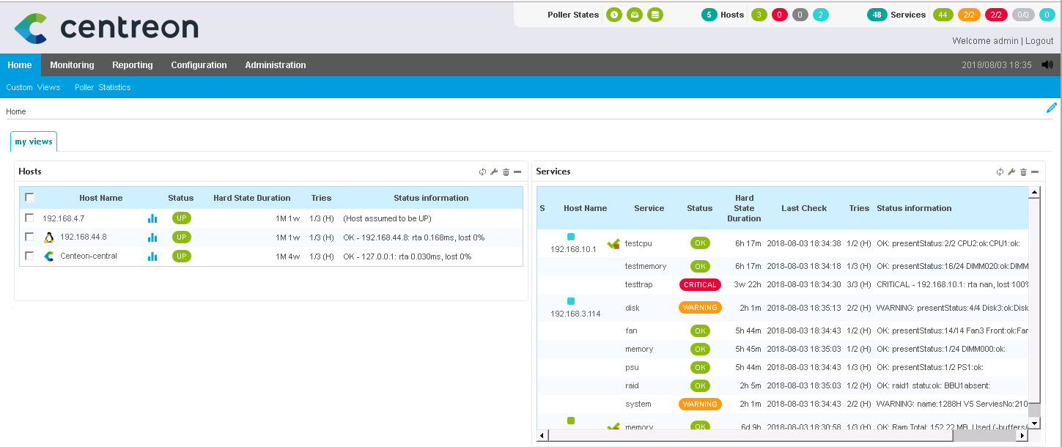

            - Choose Configuration > Commands.
The Checks page is displayed, as shown in Figure 1-1.
              - Checks page
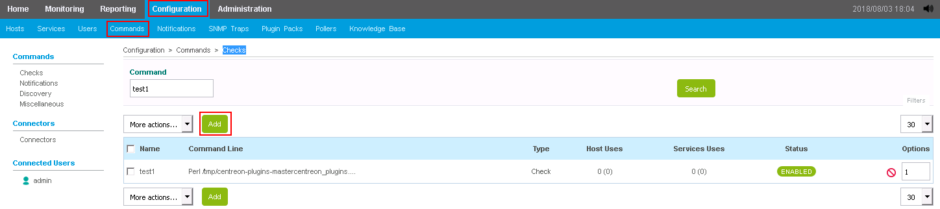
            - Click Add.
The page for adding a command is displayed, as shown in Figure 1-1.
              - Page for adding a command
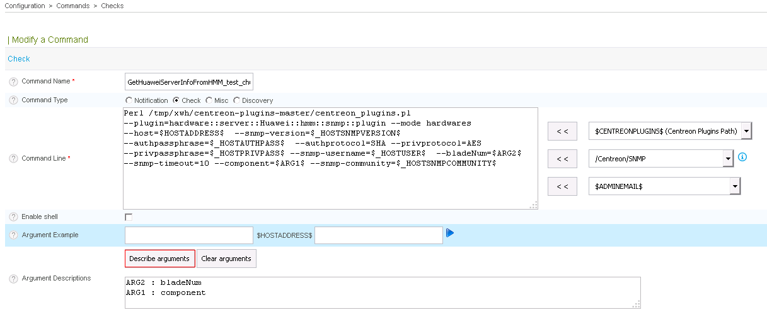

Add a command for a blade server or high-density/rack server.
- Add a command for a blade server.
  - Enter a name in Command Name, for example, GetHuaweiServerInfoFromHMM.
  - Add the following command to Command Line:
perl /usr/local/centreon-plugins-master/centreon_plugins.pl --plugin=hardware::server::huawei::hmm::snmp::plugin --mode hardwares --host=$HOSTADDRESS$ --snmp-version=$_HOSTSNMPVERSION$ --authpassphrase=$_HOSTAUTHPASS$ --authprotocol=SHA --privprotocol=AES --privpassphrase=$_HOSTPRIVPASS$ --snmp-username=$_HOSTUSER$ --bladeNum=$ARG2$ --snmp-timeout=10 --component=$ARG1$ --snmp-community=$_HOSTSNMPCOMMUNITY$
  - Click Describe arguments, and enter bladeNum and component.
- Add a command for a high-density/rack server.
  - Enter a name in Command Name, for example, GetHuaweiServerInfoFromIBMC.
  - Add the following command to Command Line:
perl /usr/local/centreon-plugins-master/centreon_plugins.pl --plugin=hardware::server::huawei::ibmc::snmp::plugin --mode hardwares --host=$HOSTADDRESS$ --snmp-version=$_HOSTSNMPVERSION$ --authpassphrase=$_HOSTAUTHPASS$ --authprotocol=SHA --privprotocol=AES --privpassphrase=$_HOSTPRIVPASS$ --snmp-username=$_HOSTUSER$ --snmp-timeout=3 --component=$ARG1$ --snmp-community=$_HOSTSNMPCOMMUNITY$
  - Click Describe arguments, and enter component.
Set /usr/local/centreon-plugins-master/centreon_plugins.pl based on the installation location of the plug-in.
Table 1-1 describes the command parameters.
                - Command parameter description
Parameter | Description | Mandatory or Optional | Example Value Description
--mode | The default value is hardwares and does not need to be changed. | Mandatory | -
--host | Specifies the IP address of the managed host. | Mandatory | In the example command, this parameter is set to $HOSTADDRESS$, which indicates that the value is transferred from the associated host configuration.
--snmp-version | Specifies the SNMP version used. | Mandatory | In the example command, this parameter is set to $_HOSTSNMPVERSION$, which indicates that the value is transferred from the associated host configuration.
--authpassphrase | Specifies the authentication password of SNMPv3. This parameter applies only to SNMPv3. | Optional | In the example command, this parameter is set to $_HOSTAUTHPASS$, which indicates that the value is transferred from the associated host configuration.
--authprotocol | Specifies the encryption protocol of SNMPv3. This parameter applies only to SNMPv3, and the value must be the same as that configured on the monitored server. | Optional | -
--privprotocol | Specifies the authentication protocol of SNMPv3. This parameter applies only to SNMPv3, and the value must be the same as that configured on the monitored server. | Optional | -
--privpassphrase | Specifies the authentication password of SNMPv3. This parameter applies only to SNMPv3. | Optional | In the example command, this parameter is set to $_HOSTPRIVPASS$, which indicates that the value is transferred from the associated host configuration.
--snmp-username | Specifies the SNMP user name. This parameter applies only to SNMPv3. | Optional | In the example command, this parameter is set to $_HOSTUSER$, which indicates that the value is transferred from the associated host configuration.
--bladeNum | Specifies the slot number of the compute node to be monitored. This parameter applies only to blade servers. | Mandatory for the monitoring of compute nodes | In the example command, this parameter is set to $ARG2$, which indicates that the value is transferred from the sevice configuration.
--snmp-timeout | Specifies the SNMP timeout interval. The default value is 1. | Optional | - The recommended value is 3 for high-density and rack servers.  - The minimum value is 10 for blade servers.
--component | Specifies the server component to be monitored.  - High-density and rack servers support the following values: system/cpu/fan/raid/memory/psu/disk  - Blade servers support the following values: system/cpu/fan/raid/memory/psu/disk/blade/shelf/switch/mezz/smm | Mandatory | In the example command, this parameter is set to $ARG1$, which indicates that the value is transferred from the sevice configuration.
--SNMP-community | Specifies the community name. This parameter applies to SNMPv2c and SNMPv1. | Optional | In the example command, this parameter is set to $_HOSTSNMPCOMMUNITY$, which indicates that the value is transferred from the associated host configuration.
--snmp-port | Specifies the SNMP port number. The default value is 161. | Optional | In the example command, this parameter is not set, and the default value is used.
--snmp-retries | Specifies the SNMP retry interval. The default value is 5. | Optional | In the example command, this parameter is not set, and the default value is used.

            - Click Save.
The command is added successfully.
----End

Configuring a Host
            - Choose Configuration > Hosts.
The Hosts page is displayed, as shown in Figure 1-1.
              - Hosts page
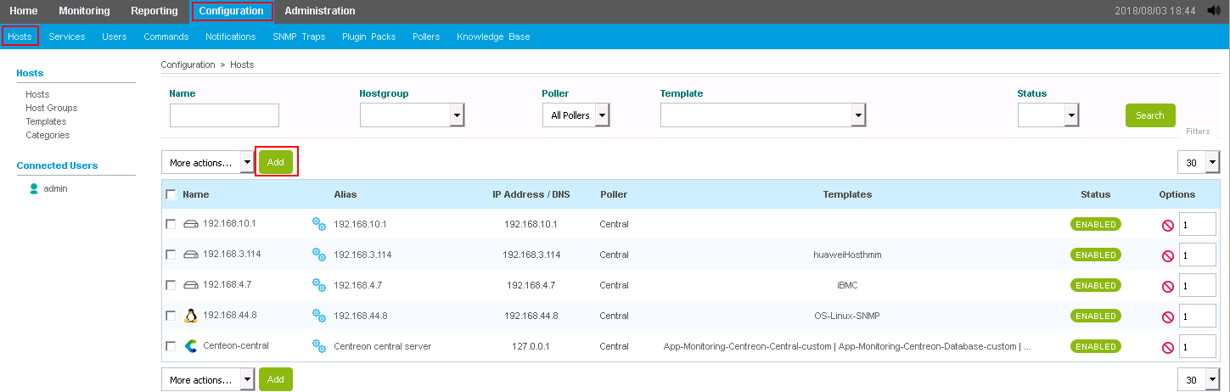

            - Click Add.
On the Add a Host page that is displayed, set the following parameters, as shown in Figure 1-1.
- Name: specifies the server host name.
- Alias: specifies the host alias.
- IP Address/DNS: specifies the server IP address.
- SNMP Community & Version: specifies the SNMP community name and version. The version must be the same as that configured on the server. The community name is required only when the version is v1 or v2c.
If SNMPv3 is used, click Add a new entry in Custom macros to add the following information about SNMPv3:
- PRIVPASS: specifies the encryption password of SNMPv3.
- AUTHPASS: specifies the authentication password of SNMPv3.
- USER: specifies the user name of SNMPv3.
              - Add a Host page
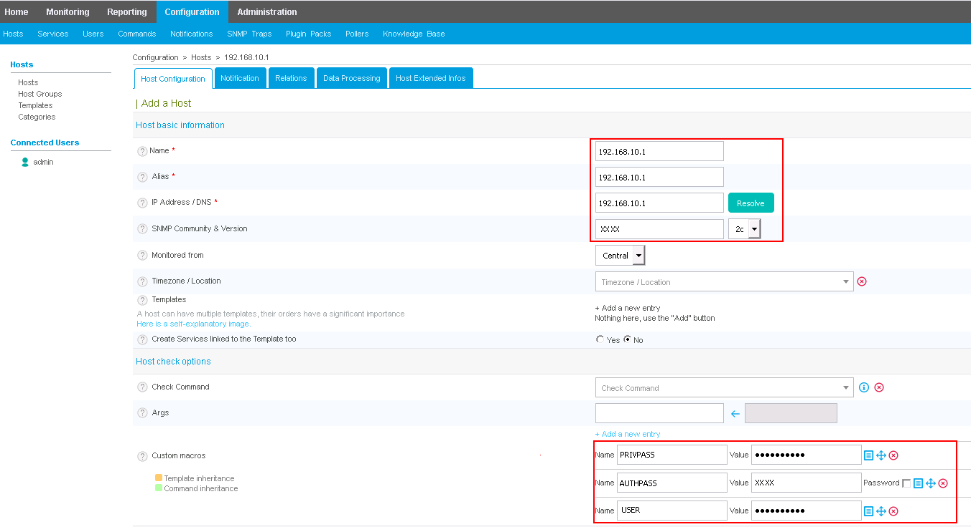

            - Click Save.
The host is configured.
----End

Configuring a Service
            - Choose Configuration > Services.
The Services page is displayed, as shown in Figure 1-1.
              - Services page
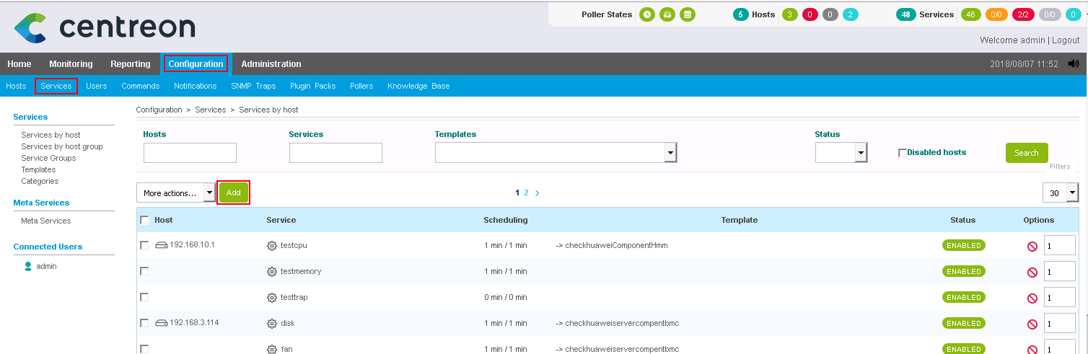
            - Click Add.
On the Add a Service page that is displayed, set related parameters, as shown in Figure 1-1.
              - Add a Service page
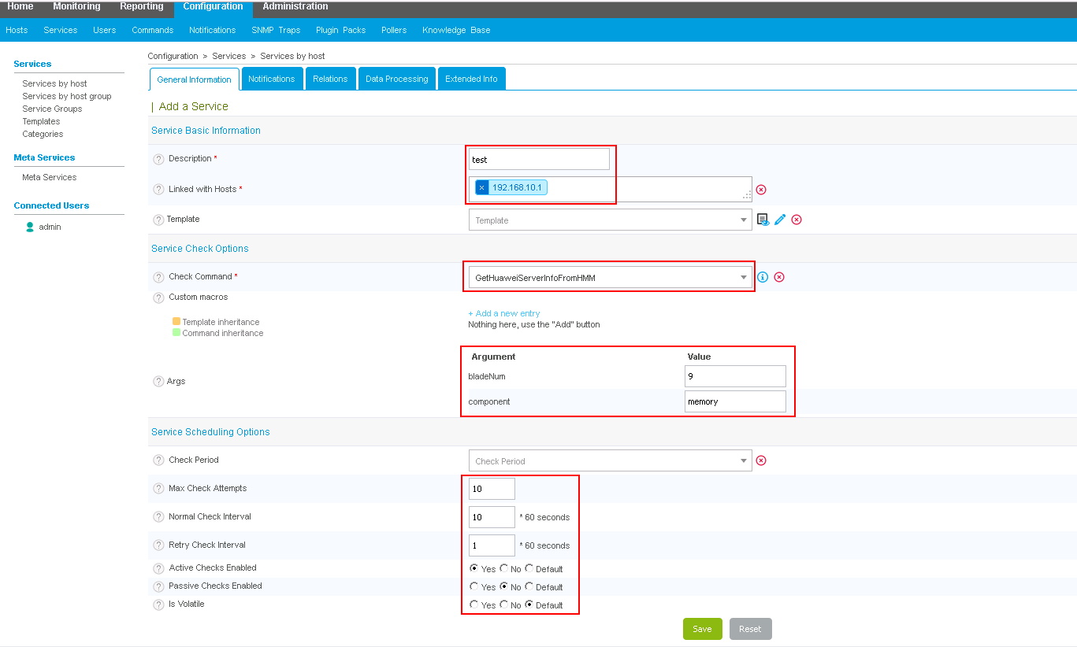
The parameters are described as follows:
- Description: specifies the name of the service to be added.
- Linked with Hosts: specifies the directly connected host. You can select the host added in 2.1.2.2 Configuring a Host.
- Check Command: You can select the command added in 2.1.2.1 Configuring a Command.
- Args:
- bladeNum: specifies the slot number of the compute node. This parameter is supported only by blade servers.
- component: specifies the server component to be monitored. For details about the value range, see Table 1-1.
- Max Check Attempts: specifies the maximum retry times.
- Normal Check Interval: specifies the regular monitoring interval.
- Retry Check Interval: specifies the interval for retrying monitoring.
- Active Checks Enabled: specifies whether to enable proactive monitoring. Set this parameter to Yes.
- Passive Checks Enabled: specifies whether to enable passive monitoring. Set this parameter to No.
- Is Volatile: Set this parameter to Default.
            - Click Save.
The service is configured.
----End

Generating a Configuration File and Making the ConfigurationTake Effect
            - Choose Configuration > Pollers.
The Pollers page is displayed, as shown in Figure 1-1.
              - Pollers page
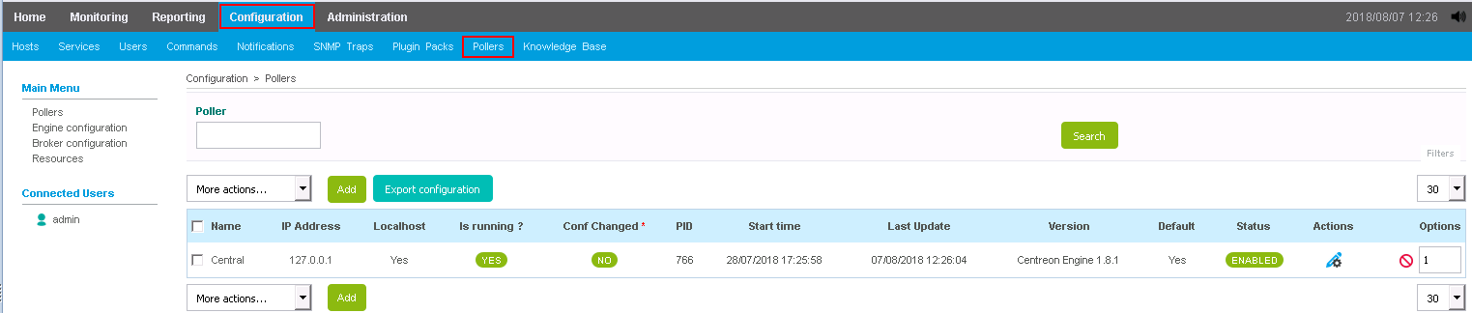
            - Select an available poller, and click Export Configuration.
            - Select all parameters in Actions, and click Export.
If Total Errors: 0 is displayed in the export results, the export is successful and the configuration takes effect.
              - Configuration Files Export page
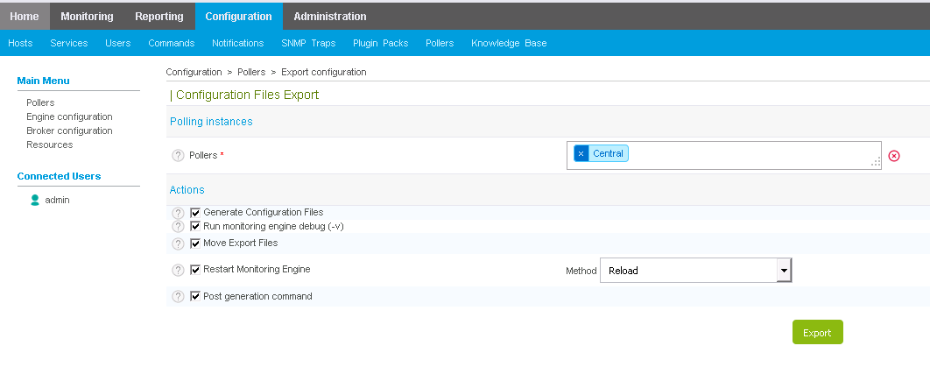

----End

Viewing the Server Status
            - Choose Monitoring > Status Details. Select All from the Service Status drop-down list box to view the status of all monitored hosts.
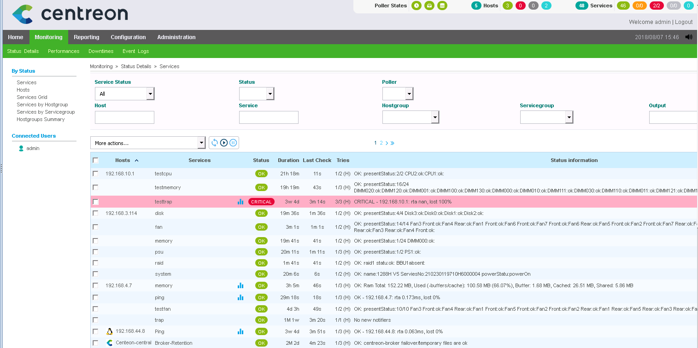
----End

Receiving Server SNMP Alarms
SNMP trap alarms can be received only in SNMPv2c and SNMPv3.
Prerequisites
To receive SNMPv3 alarms, you need to download the MIB Browser tool to view the engine ID of the server.

Configuring Server Trap Parameters

Configuring a Rack/High-Density Server
            - Log in to the iBMC of the rack/high-density server. For details, see the iBMC user guide of the corresponding product.
            - Choose Alarm & SEL > Alarm Settings, enable the trap function, and set the following parameters, as shown in Figure 1-1.
- Trap Version: Select the corresponding version according to the actual situation.
- Trap Mode: Select OID.
- Set the following parameters in the Trap Server and Message Format area:
- Trap Server Address: Enter the centreon server IP address.
- Trap Port: Enter 162.
              - iBMC alarm settings
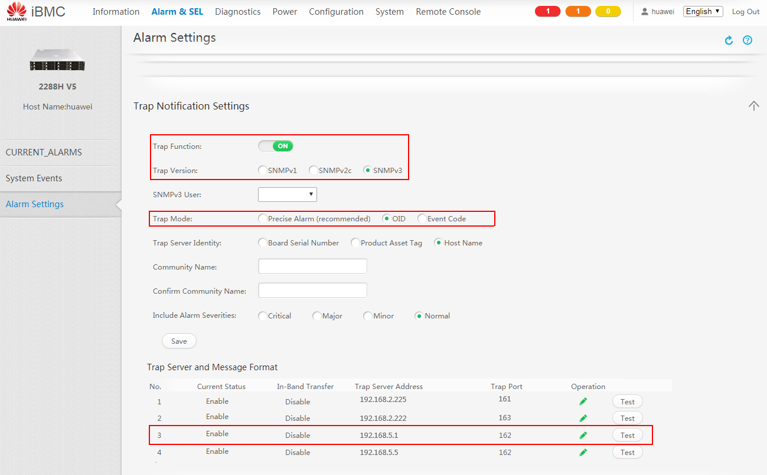

----End

Configuring a Blade Server
            - Log in to the HMM WebUI of the blade server. For details, see the MM910 Management Module V100R001 User Guide.
            - Choose Chassis Settings > Network Settings > MM. In SNMP TrapConfiguration, set Trap to Enable, and set the following parameters:
- Trap version: Select the corresponding version according to the actual situation.
- Trap mode: Select OID mode.
- Trap port number: Enter 162.
- Trap address: Enter the centreon server IP address.
              - HMM SNMP trap configuration
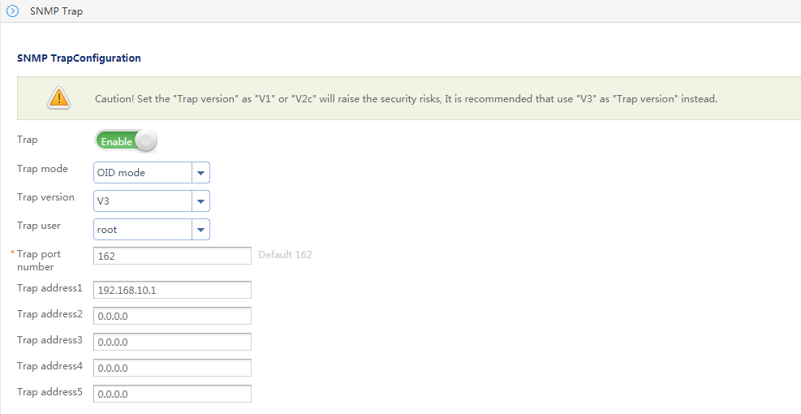

----End

Receiving SNMPv2c Alarms

Importing the MIB File
            - Log in to centreon.
- Open the browser, enter http://centreon IP address/centreon in the address box, and press Enter.
- Enter the user name and password, and click Login.
The centreon home page is displayed, as shown in Figure 1-1.
              - Home page of centreon

            - Choose Configuration > SNMP Traps. The SNMP Traps page is displayed.
Choose Manufacturer in the navigation tree, and click Add in the right pane, as shown in Figure 1-1.
              - Page for adding a Huawei vendor
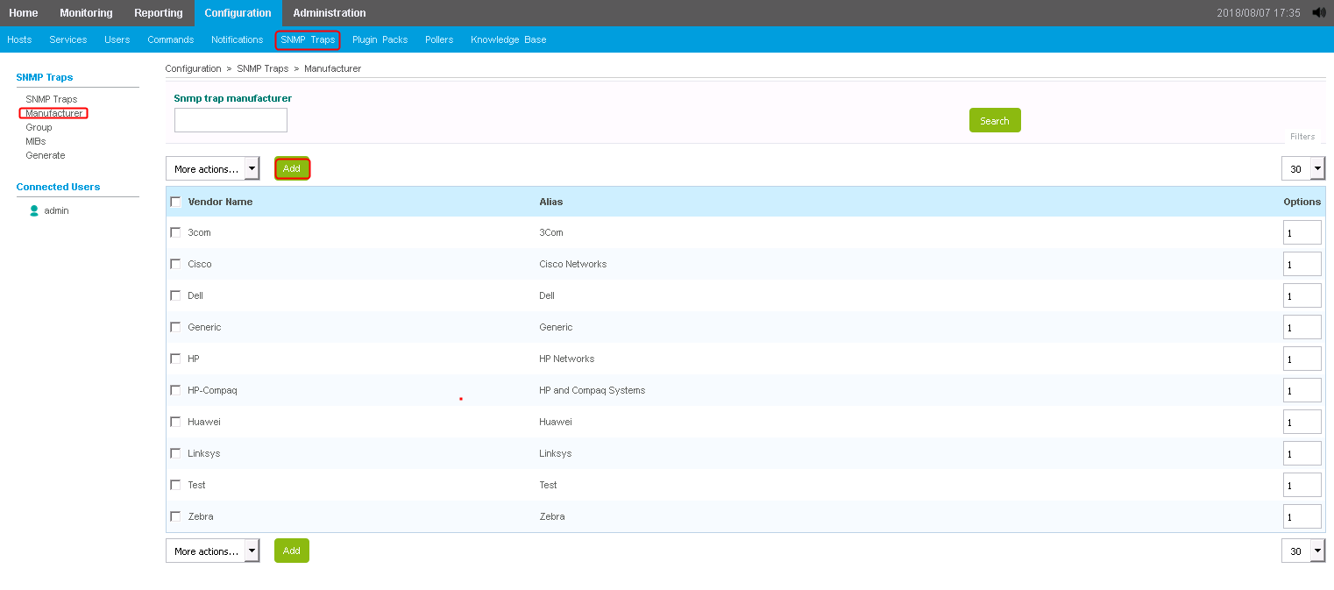
            - Add a Huawei vendor and click Save, as shown in Figure 1-1.
The parameters are described as follows:
- Vendor Name: Enter Huawei.
- Alias: Enter an alias.
              - Add Vendor page
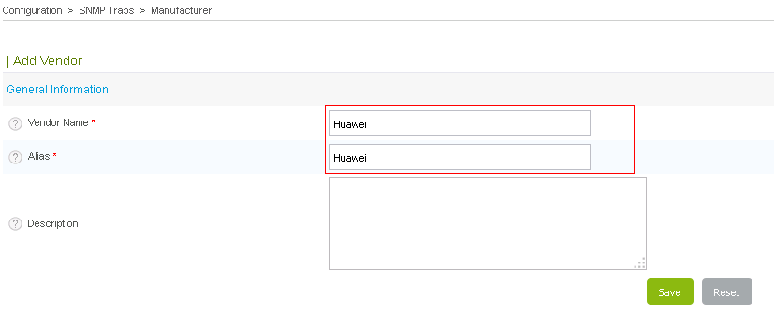

            - Install the plug-in extension package that supports Huawei servers.
- Run the following command to switch to the centreon server directory:
cd /tmp
- Run the following command to install the Huawei centreon plug-in software package:
#git clone https://github.com/serverplugin/Server_Management_Plugin_Centreon.git
- Go to the /Server_Management_Plugin_Centreon/releases directory and run the following command to decompress the Huawei centreon plug-in software package:
tar -xzvf centreonPluginForHuaweiServer_v1.0.tar.gz
            - Run the following commands to go to the directory and import the iBMC or HMM MIB file to Huawei.
- Run the following commands for a high-density/rack server:
cd /tmp/src/
perl importMib.pl -f huaweimib/bmcForCentreon.mib -m Huawei
- Run the following commands for a blade server:
cd /tmp/src/
perl importMib.pl -f huaweimib/hmmForCentreon.mib -m Huawei
            - Choose Configuration > SNMP Traps > Generate, select an available poller, set Send Signal to Restart, select all parameters in Actions, and click Generate. The trap configuration is generated, as shown in Figure 1-1.
              - Page for generating the trap configuration
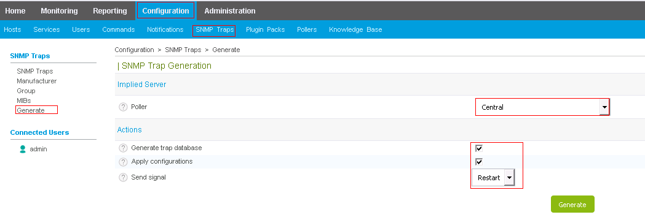

----End

Configuring a Receiving Host
            - Log in to centreon.
- Open the browser, enter http://centreon IP address/centreon in the address box, and press Enter.
- Enter the user name and password, and click Login.
The centreon home page is displayed, as shown in Figure 1-1.
              - Home page of centreon

            - Choose Configuration > Hosts.
The Hosts page is displayed, as shown in Figure 1-1.
              - Hosts page

            - Click Add.
The Add a Host page is displayed.
Set the following parameters, as shown in Figure 1-1.
- Name: specifies the server host name.
- Alias: specifies the host alias.
- IP Address/DNS: specifies the server IP address.
              - Add a Host page
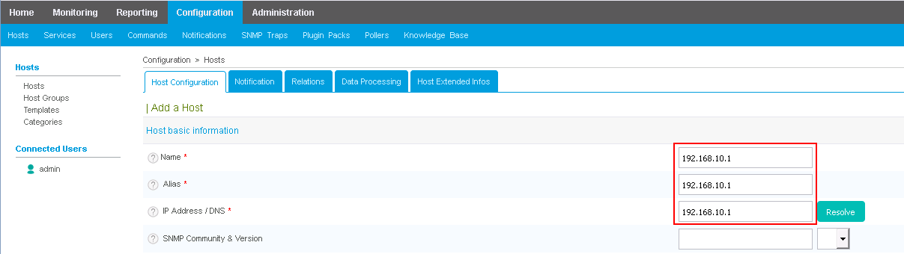

            - Click Save.
----End

Creating a Service and Associating it with a Host and a Trap
            - Choose Configuration > Services.
The Services page is displayed, as shown in Figure 1-1.
              - Services page
            - Click Add. The Add a Service page is displayed.
On the General Information tab, set the following parameters, as shown in Figure 1-1.
              - Add a Service page
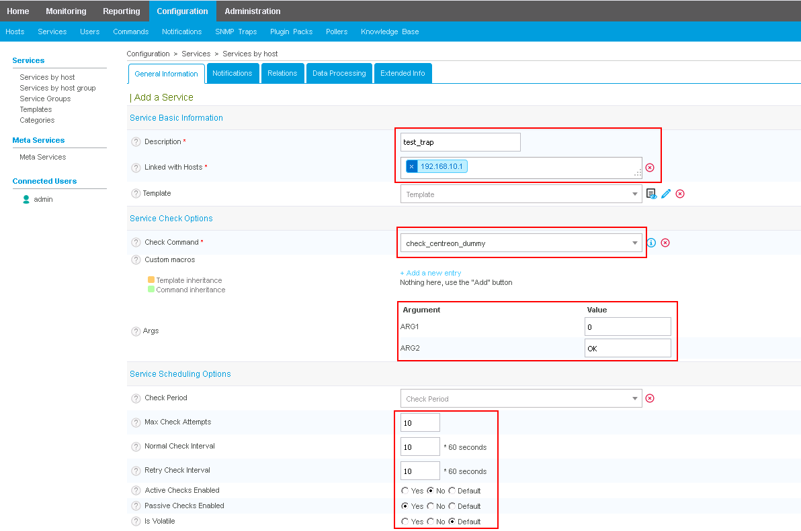
The parameters are described as follows:
- Description: specifies the name of the service to be added.
- Linked with Hosts: specifies the directly connected host. You can select the host added in 2.2.2.2 Configuring a Receiving Host.
- Check Command: Select Check_centreon_dummy.
- Args:
- ARG1: Enter 0.
- ARG2: Enter OK.
- Max Check Attempts: specifies the maximum retry times.
- Normal Check Interval: specifies the regular monitoring interval.
- Retry Check Interval: specifies the interval for retrying monitoring.
- Active Checks Enabled: specifies whether to enable proactive monitoring. Set this parameter to No.
- Passive Checks Enabled: specifies whether to enable passive monitoring. Set this parameter to Yes.
- Is Volatile: Set this parameter to Default.
            - On the Relations tab, enter the associated trap information, as shown in Figure 1-1.
              - Add relations page
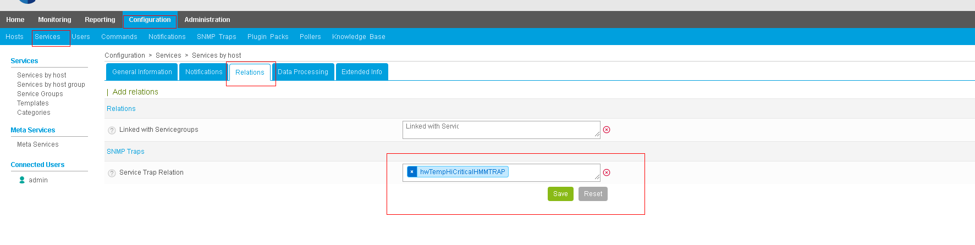

            - Click Save.
----End

Generating a Configuration File and Making the ConfigurationTake Effect
            - Choose Configuration > Pollers.
The Pollers page is displayed, as shown in Figure 1-1.
              - Pollers page
            - Select an available poller, and click Export Configuration.
            - Select all parameters in Actions, and click Export.
If Total Errors: 0 is displayed in the export results, the export is successful and the configuration takes effect.
              - Configuration Files Export page

----End

Receiving Alarms
            - Choose Monitoring > Status Details. Select All from the Service Status drop-down list box to view the alarm information.
----End

Receiving SNMPv3 Alarms

Obtaining the Engine ID
            - In the main window of the MIB Browser tool, click .
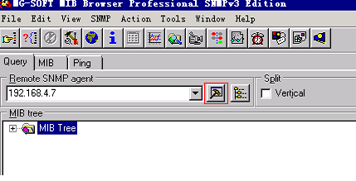
            - In the displayed dialog box, click Edit User.
              - SNMP Protocol Preferences
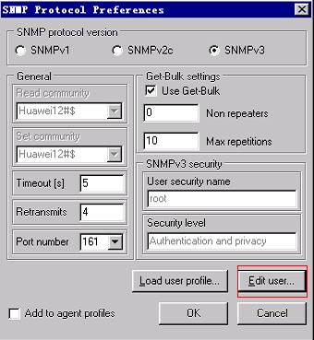

            - Add an SNMPv3 user name, set Authentication protocol to HMAC-SHA and Privacy protocol to CFB-AES-128, click Change Password to change the passwords, and click OK.
              - SNMPv3 Security Parameters
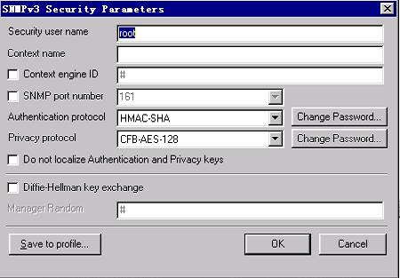

            - Query the engine ID in the query results, as shown in Figure 1-1.
              - Query results
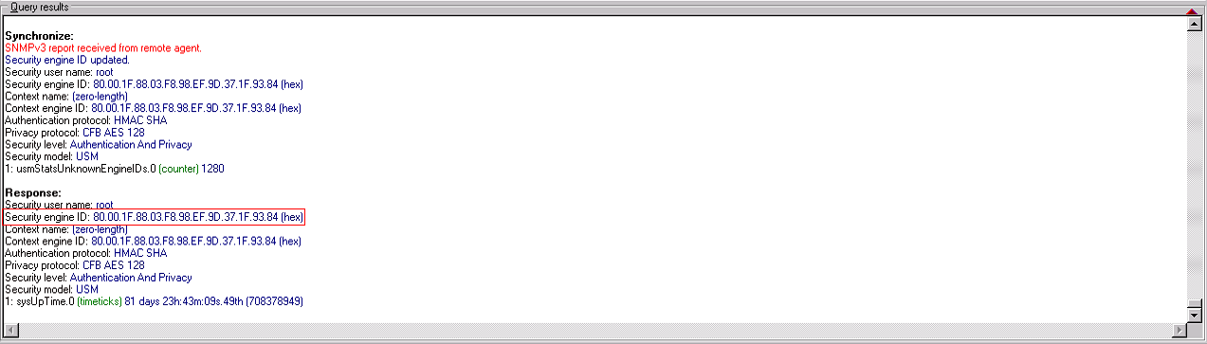

----End

Configuring the Authentication User Information
            - Use PuTTY to log in to the centreon server by using SSH.
            - Add SNMPv3 authentication information. Perform this operation only when SNMPv3 is used.
Run the following command to modify the file:
vi /etc/SNMP/SNMPtrapd.conf
Add a line of authentication configuration, as shown in Figure 1-1.
createUser –e engineId username authprotocol authpass privprotocol privpass


Passwords are displayed in plain text here, which poses security risks. For security-sensitive users, contact centreon.
              - Adding authentication information
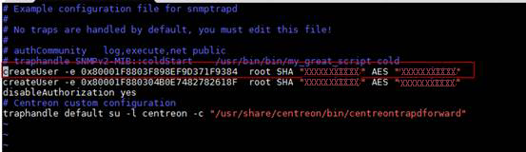

            - Log in to centreon.
- Open the browser, enter http://centreon IP address/centreon in the address box, and press Enter.
- Enter the user name and password, and click Login.
The centreon home page is displayed, as shown in Figure 1-1.
              - Home page of centreon

            - Choose Configuration > SNMP Traps. The SNMP Traps page is displayed.
Choose Manufacturer in the navigation tree, and click Add in the right pane, as shown in Figure 1-1.
              - Page for adding a Huawei vendor
            - Install the plug-in extension package that supports Huawei servers.
- Run the following command to switch to the centreon server directory:
cd /tmp
- Run the following command to install the Huawei centreon plug-in software package:
#git clone https://github.com/serverplugin/Server_Management_Plugin_Centreon.git
- Go to the /Server_Management_Plugin_Centreon/releases directory and run the following command to decompress the Huawei centreon plug-in software package:
tar -xzvf centreonPluginForHuaweiServer_v1.0.tar.gz
            - Run the following commands to go to the directory and import the iBMC or HMM MIB file to Huawei.
- Run the following commands for a high-density/rack server:
cd /tmp/src/
perl importMib.pl -f huaweimib/bmcForCentreon.mib -m Huawei
- Run the following commands for a blade server:
cd /tmp/src/
perl importMib.pl -f huaweimib/hmmForCentreon.mib -m Huawei
            - Choose Configuration > SNMP Traps > Generate, select an available poller, set Send Signal to Restart, select all parameters in Actions, and click Generate. The trap configuration is generated, as shown in Figure 1-1.
              - Page for generating the trap configuration

----End

Configuring a Receiving Host
            - Log in to centreon.
- Open the browser, enter http://centreon IP address/centreon in the address box, and press Enter.
- Enter the user name and password, and click Login.
The centreon home page is displayed, as shown in Figure 1-1.
              - Home page of centreon

            - Choose Configuration > Hosts.
The Hosts page is displayed, as shown in Figure 1-1.
              - Hosts page

            - Click Add.
The Add a Host page is displayed.
Set the following parameters, as shown in Figure 1-1.
- Name: specifies the server host name.
- Alias: specifies the host alias.
- IP Address/DNS: specifies the server IP address.
              - Add a Host page

            - Click Save.
----End

Creating a Service and Associating it with a Host and a Trap
            - Choose Configuration > Services.
The Services page is displayed, as shown in Figure 1-1.
              - Services page
            - Click Add. The Add a Service page is displayed.
On the General Information tab, set the following parameters, as shown in Figure 1-1.
              - Add a Service page
The parameters are described as follows:
- Description: specifies the name of the service to be added.
- Linked with Hosts: specifies the directly connected host. You can select the host added in 2.2.2.2 Configuring a Receiving Host.
- Check Command: Select Check_centreon_dummy.
- Args:
- ARG1: Enter 0.
- ARG2: Enter OK.
- Max Check Attempts: specifies the maximum retry times.
- Normal Check Interval: specifies the regular monitoring interval.
- Retry Check Interval: specifies the interval for retrying monitoring.
- Active Checks Enabled: specifies whether to enable proactive monitoring. Set this parameter to No.
- Passive Checks Enabled: specifies whether to enable passive monitoring. Set this parameter to Yes.
- Is Volatile: Set this parameter to Default.
            - On the Relations tab, enter the associated trap information, as shown in Figure 1-1.
              - Add relations page

            - Click Save.
----End

Generating a Configuration File and Making the ConfigurationTake Effect
            - Choose Configuration > Pollers.
The Pollers page is displayed, as shown in Figure 1-1.
              - Pollers page
            - Select an available poller, and click Export Configuration.
            - Select all parameters in Actions, and click Export.
If Total Errors: 0 is displayed in the export results, the export is successful and the configuration takes effect.
              - Configuration Files Export page

----End

Receiving Alarms
            - Choose Monitoring > Status Details. Select All from the Service Status drop-down list box to view the alarm information.
----End

Using centreon (Version 2.3.8)
In this chapter, centreon 2.3.8 is used.

When SNMPv3 is configured for centreon 2.3.8, the user name, encryption password, and authentication password are displayed in plain text, which poses security risks. You are advised to upgrade the centreon software version for security-sensitive users.
3.1 Monitoring the Server Health Status
3.2 Receiving Server SNMP Alarms

Monitoring the Server Health Status

Installing and Uninstalling the Huawei centreon Plug-in

Installing the centreon Plug-in
            - Use the SSH mode (such as PuTTY) to log in to the centreon server.
            - Run the following commands to install the official centreon plug-in:
# yum install git
# git clone https://github.com/centreon/centreon-plugins.git
            - Copy the centreon-plugins folder from the current directory to the installation directory, for example, /usr/local/.
            - Install the plug-in extension package that supports Huawei servers.
- Run the following command to switch to the centreon server directory:
cd /tmp
- Run the following command to install the Huawei centreon plug-in software package:
#git clone https://github.com/Huawei/Server_Management_Plugin_Centreon.git
- Go to the /Server_Management_Plugin_Centreon/releases directory and run the following command to decompress the Huawei centreon plug-in software package:
tar -xzvf centreonPluginForHuaweiServer_v1.0.tar.gz
- Run the following command to copy the content from the hardware/ directory in the decompressed package to the hardware/ directory in the centreon installation directory. For example, if the directory where the hardware directory of centreon is located is /usr/local/centreon-plugins, run the following command:
cp -rf /tmp/src/hardware /usr/local/centreon-plugins/
----End

Uninstalling the centreon Plug-in
            - Use the SSH mode (such as PuTTY) to log in to the centreon server.
            - Find the hardware/server/huawei directory in the plug-in installation directory, and run the following command to delete the directory:
rm -rf /usr/local/centreon-plugins-master/hardware/server/huawei
----End

Configuring the Server Health Status Monitoring Function
Perform the following operations to implement the function of server health status monitoring.

Configuring a Command
            - Log in to centreon.
- Open the browser, enter http://centreon IP address/centreon in the address box, and press Enter.
- Enter the user name and password, and click Login.
The centreon home page is displayed, as shown in Figure 1-1.
              - Home page of centreon
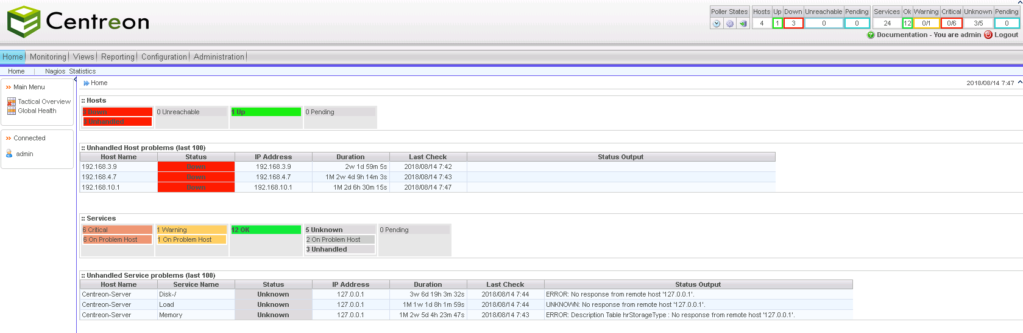

            - Choose Configuration > Commands.
The Checks page is displayed, as shown in Figure 1-1.
              - Checks
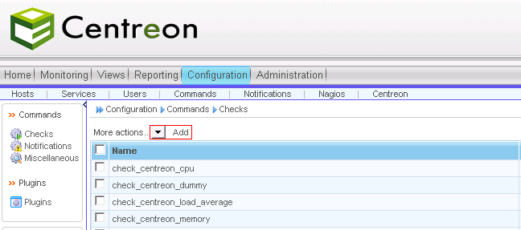
            - Click Add.
The page for adding a command is displayed, as shown in Figure 1-1.
              - Page for adding a command
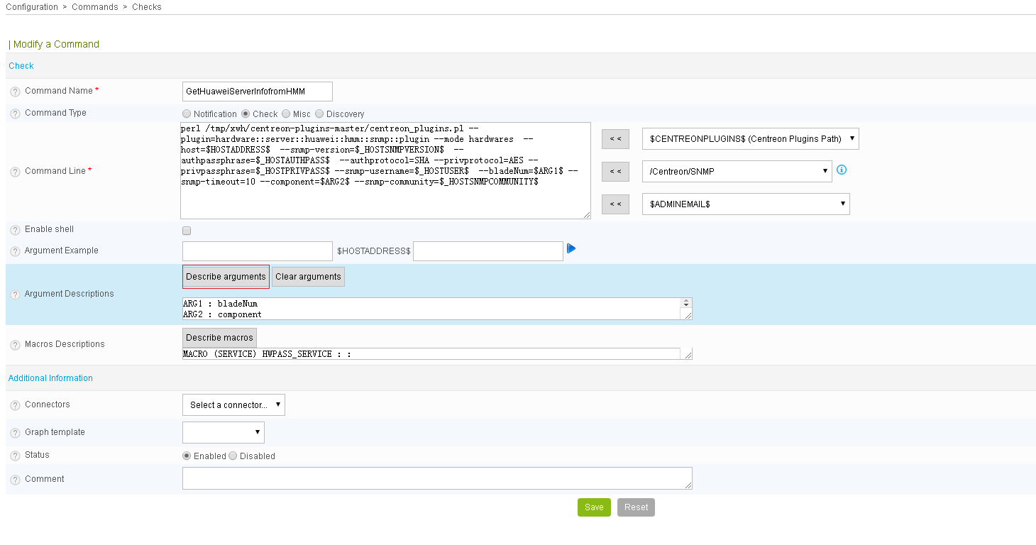

Add a command for a blade server or high-density/rack server.
- Add a command for a blade server.
  - Enter a name in Command Name, for example, GetHuaweiServerInfoFromHMM.
  - Add the following command to Command Line:
perl /usr/local/centreon-plugins-master/centreon_plugins.pl --plugin=hardware::server::huawei::hmm::snmp::plugin --mode hardwares --host=$HOSTADDRESS$ --snmp-version=$_HOSTSNMPVERSION$ --authpassphrase=$_HOSTAUTHPASS$ --authprotocol=SHA --privprotocol=AES --privpassphrase=$_HOSTPRIVPASS$ --snmp-username=$_HOSTUSER$ --bladeNum=$ARG2$ --snmp-timeout=10 --component=$ARG1$ --snmp-community=$_HOSTSNMPCOMMUNITY$
  - Click Describe arguments, and enter bladeNum and component.
- Add a command for a high-density/rack server.
  - Enter a name in Command Name, for example, GetHuaweiServerInfoFromIBMC.
  - Add the following command to Command Line:
perl /usr/local/centreon-plugins-master/centreon_plugins.pl --plugin=hardware::server::huawei::ibmc::snmp::plugin --mode hardwares --host=$HOSTADDRESS$ --snmp-version=$_HOSTSNMPVERSION$ --authpassphrase=$_HOSTAUTHPASS$ --authprotocol=SHA --privprotocol=AES --privpassphrase=$_HOSTPRIVPASS$ --snmp-username=$_HOSTUSER$ --snmp-timeout=3 --component=$ARG1$ --snmp-community=$_HOSTSNMPCOMMUNITY$
  - Click Describe arguments, and enter component.
Set /usr/local/centreon-plugins-master/centreon_plugins.pl based on the installation location of the plug-in.
Table 1-1 describes the command parameters.
                - Command parameter description
Parameter | Description | Mandatory or Optional | Example Value Description
--mode | The default value is hardwares and does not need to be changed. | Mandatory | -
--host | Specifies the IP address of the managed host. | Mandatory | In the example command, this parameter is set to $HOSTADDRESS$, which indicates that the value is transferred from the associated host configuration.
--snmp-version | Specifies the SNMP version used. | Mandatory | In the example command, this parameter is set to $_HOSTSNMPVERSION$, which indicates that the value is transferred from the associated host configuration.
--authpassphrase | Specifies the authentication password of SNMPv3. This parameter applies only to SNMPv3. | Optional | In the example command, this parameter is set to $_HOSTAUTHPASS$, which indicates that the value is transferred from the associated host configuration.
--authprotocol | Specifies the encryption protocol of SNMPv3. This parameter applies only to SNMPv3, and the value must be the same as that configured on the monitored server. | Optional | -
--privprotocol | Specifies the authentication protocol of SNMPv3. This parameter applies only to SNMPv3, and the value must be the same as that configured on the monitored server. | Optional | -
--privpassphrase | Specifies the authentication password of SNMPv3. This parameter applies only to SNMPv3. | Optional | In the example command, this parameter is set to $_HOSTPRIVPASS$, which indicates that the value is transferred from the associated host configuration.
--snmp-username | Specifies the SNMP user name. This parameter applies only to SNMPv3. | Optional | In the example command, this parameter is set to $_HOSTUSER$, which indicates that the value is transferred from the associated host configuration.
--bladeNum | Specifies the slot number of the compute node to be monitored. This parameter applies only to blade servers. | Mandatory for the monitoring of compute nodes | In the example command, this parameter is set to $ARG2$, which indicates that the value is transferred from the sevice configuration.
--snmp-timeout | Specifies the SNMP timeout interval. The default value is 1. | Optional | - The recommended value is 3 for high-density and rack servers.  - The minimum value is 10 for blade servers.
--component | Specifies the server component to be monitored.  - High-density and rack servers support the following values: system/cpu/fan/raid/memory/psu/disk  - Blade servers support the following values: system/cpu/fan/raid/memory/psu/disk/blade/shelf/switch/mezz/smm | Mandatory | In the example command, this parameter is set to $ARG1$, which indicates that the value is transferred from the sevice configuration.
--SNMP-community | Specifies the community name. This parameter applies to SNMPv2c and SNMPv1. | Optional | In the example command, this parameter is set to $_HOSTSNMPCOMMUNITY$, which indicates that the value is transferred from the associated host configuration.
--snmp-port | Specifies the SNMP port number. The default value is 161. | Optional | In the example command, this parameter is not set, and the default value is used.
--snmp-retries | Specifies the SNMP retry interval. The default value is 5. | Optional | In the example command, this parameter is not set, and the default value is used.

            - Click Save.
The command is added successfully.
----End

Configuring a Host
            - Choose Configuration > Hosts.
The Hosts page is displayed, as shown in Figure 1-1.
              - Hosts page
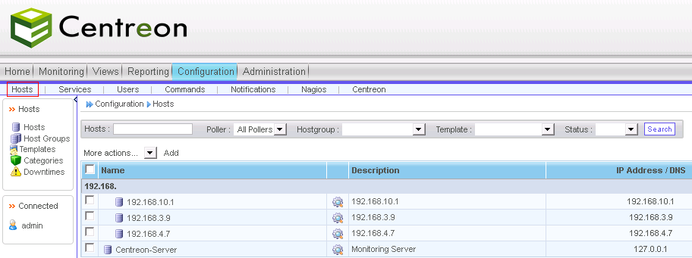

            - Click Add.
The Add a Host page is displayed.
Set the following parameters, as shown in Figure 1-1.
- Name: specifies the server host name.
- Alias: specifies the host alias.
- IP Address/DNS: specifies the server IP address.
- SNMP Community & Version: specifies the SNMP community name and version. The version must be the same as that configured on the server. The community name is required only when the version is v1 or v2c.
If SNMPv3 is used, click in Custom macros under Macros to add the following information about SNMPv3.

When SNMPv3 is configured for centreon 2.3.8, the user name, encryption password, and authentication password are displayed in plain text, which poses security risks. You are advised to upgrade the centreon software version for security-sensitive users.
- PRIVPASS: specifies the encryption password of SNMPv3.
- USER: specifies the user name of SNMPv3.
- AUTHPASS: specifies the authentication password of SNMPv3.
              - Add a Host page
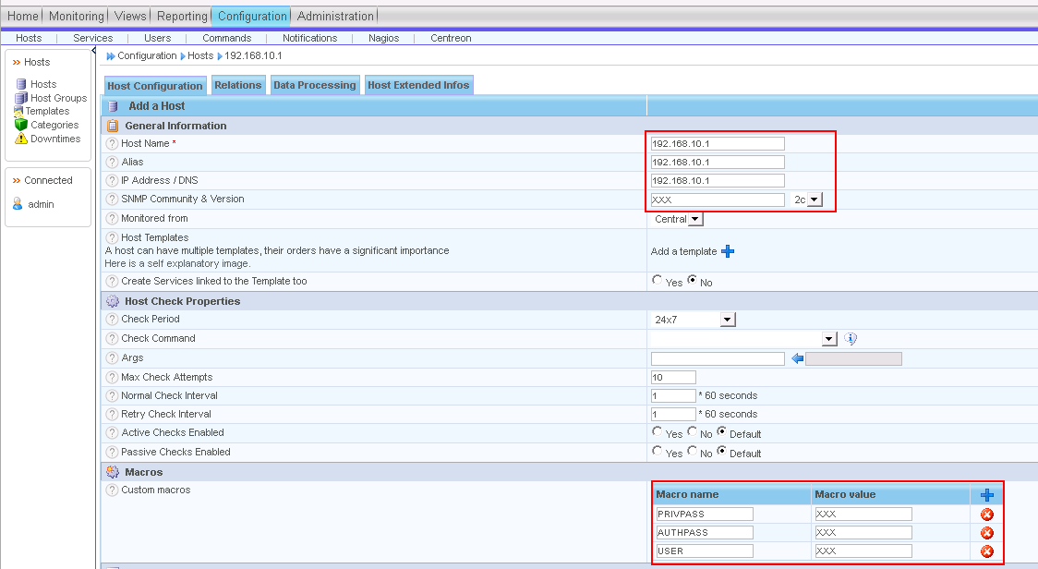

            - Click Save.
The host is configured.
----End

Configuring a Service
            - Choose Configuration > Services.
The Services page is displayed, as shown in Figure 1-1.
              - Services page
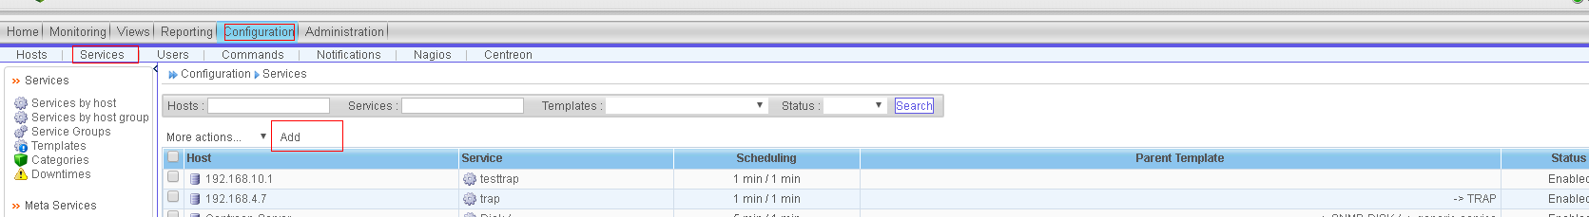
            - Click Add.
On the Add a Service page that is displayed, set mandatory parameters, as shown in Figure 1-1.
              - Add a Service page
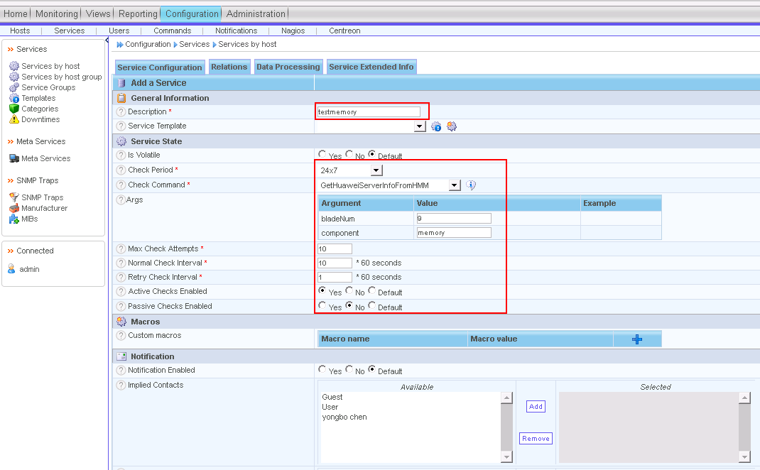
The parameters are described as follows:
- Description: specifies the name of the service to be added.
- Check Period: Select 24x7.
- Check Command: You can select the command added in 3.1.2.1 Configuring a Command.
- Args:
- bladeNum: specifies the slot number of the compute node. This parameter is supported only by blade servers.
- component: specifies the server component to be monitored. For details about the value range, see Table 1-1.
- Max Check Attempts: specifies the maximum retry times.
- Normal Check Interval: specifies the regular monitoring interval.
- Retry Check Interval: specifies the interval for retrying monitoring.
- Active Checks Enabled: specifies whether to enable proactive monitoring. Set this parameter to Yes.
- Passive Checks Enabled: specifies whether to enable passive monitoring. Set this parameter to No.
            - Click Save.
            - Click the Relations tab, select the associated host from the Available list in the left area of Linked with Hosts, and click Add to add the host to the Selected list in the right area, as shown in Figure 1-1. Then click Save.
The parameters are described as follows:
- Linked with Hosts: specifies the directly connected host. You can select the host configured in 3.1.2.2 Configuring a Host.
              - Add relations page
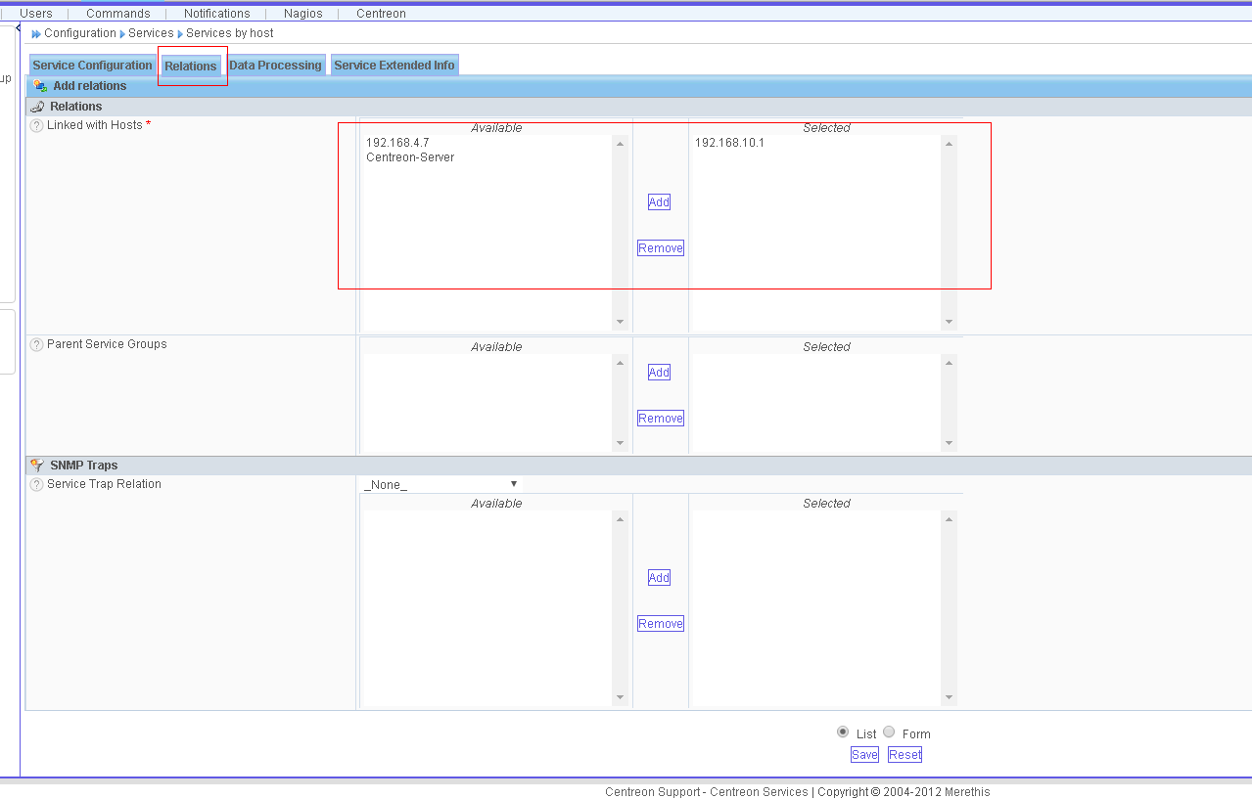

The service is configured.
----End

Generating a Configuration File and Making the ConfigurationTake Effect
            - Choose Configuration > Nagios, select all parameters in Actions, and click Export, as shown in Figure 1-1.
If Total Errors: 0 is displayed in the export results, the export is successful and the configuration takes effect.
              - Nagios page
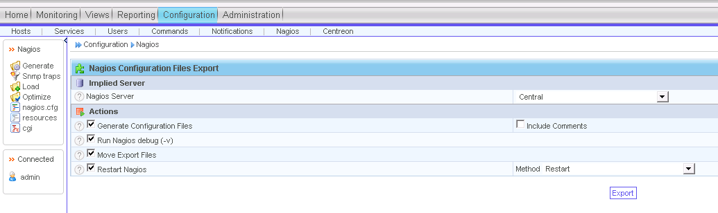
----End

Viewing the Server Status
            - Choose Monitoring > Services > All Services to view the status of all monitored hosts, as shown in Figure 1-1.
              - All Services page
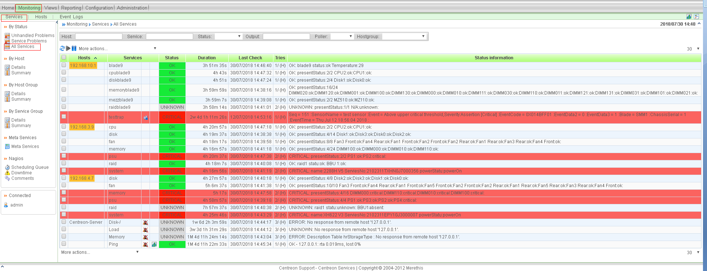

----End

Receiving Server SNMP Alarms
SNMP trap alarms can be received only in SNMPv2c and SNMPv3.
Prerequisites
To receive SNMPv3 alarms, you need to download the MIB Browser tool to view the engine ID of the server.

Configuring Server Trap Parameters

Configuring a Rack/High-Density Server
            - Log in to the iBMC of the rack/high-density server. For details, see the iBMC user guide of the corresponding product.
            - Choose Alarm & SEL > Alarm Settings, enable the trap function, and set the following parameters, as shown in Figure 1-1.
- Trap Version: Select the corresponding version according to the actual situation.
- Trap Mode: Select OID.
- Set the following parameters in the Trap Server and Message Format area:
- Trap Server Address: Enter the centreon server IP address.
- Trap Port: Enter 162.
              - iBMC alarm settings

----End

Configuring a Blade Server
            - Log in to the HMM WebUI of the blade server. For details, see the MM910 Management Module V100R001 User Guide.
            - Choose Chassis Settings > Network Settings > MM. In SNMP TrapConfiguration, set Trap to Enable, and set the following parameters:
- Trap version: Select the corresponding version according to the actual situation.
- Trap mode: Select OID mode.
- Trap port number: Enter 162.
- Trap address: Enter the centreon server IP address.
              - HMM SNMP trap configuration

----End

Receiving SNMPv2c Alarms

Importing the MIB File
            - Log in to centreon.
- Open the browser, enter http://centreon IP address/centreon in the address box, and press Enter.
- Enter the user name and password, and click Login.
The centreon home page is displayed, as shown in Figure 1-1.
              - Home page of centreon

            - Choose Configuration > Services, choose Manufacturer in the navigation tree, and click Add in the right pane, as shown in Figure 1-1.
              - Page for adding a Huawei vendor
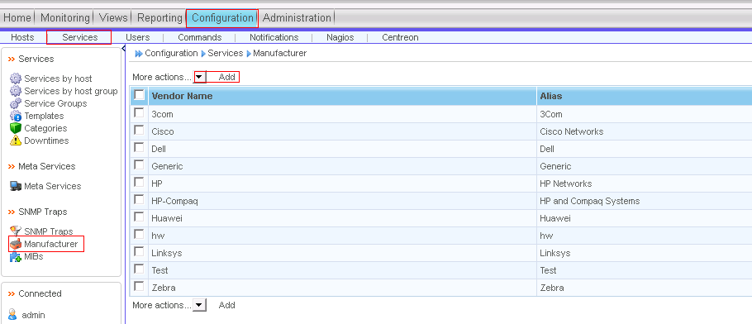
            - Add a Huawei vendor and click Save, as shown in Figure 1-1.
The parameters are described as follows:
- Vendor Name: Enter Huawei.
- Alias: Enter an alias.
              - Add Vendor page
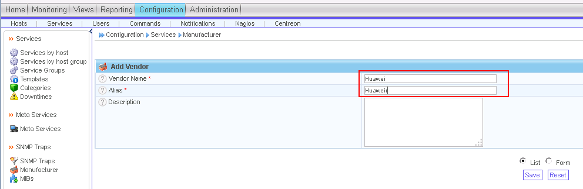

            - Install the plug-in extension package that supports Huawei servers.
- Run the following command to switch to the centreon server directory:
cd /tmp
- Run the following command to install the Huawei centreon plug-in software package:
#git clone https://github.com/serverplugin/Server_Management_Plugin_Centreon.git
- Go to the /Server_Management_Plugin_Centreon/releases directory and run the following command to decompress the Huawei centreon plug-in software package:
tar -xzvf centreonPluginForHuaweiServer_v1.0.tar.gz
            - Run the following commands to go to the directory and import the iBMC or HMM MIB file to Huawei.
- Run the following commands for a high-density/rack server:
cd /tmp/src/
perl importMib.pl -f huaweimib/bmcForCentreon.mib -m Huawei
- Run the following commands for a blade server:
cd /tmp/src/
perl importMib.pl -f huaweimib/hmmForCentreon.mib -m Huawei
            - Choose Configuration > Nagios > Snmp traps, select an available Nagios server, select all parameters in Actions, and click Generate. The trap configuration is generated, as shown in Figure 1-1.
              - Page for generating the trap configuration
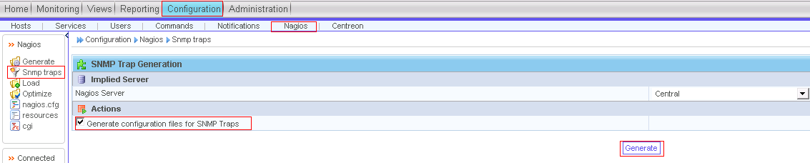
----End

Configuring a Receiving Host
            - Log in to centreon.
- Open the browser, enter http://centreon IP address/centreon in the address box, and press Enter.
- Enter the user name and password, and click Login.
The centreon home page is displayed, as shown in Figure 1-1.
              - Home page of centreon

            - Choose Configuration > Hosts.
The Hosts page is displayed, as shown in Figure 1-1.
              - Hosts page
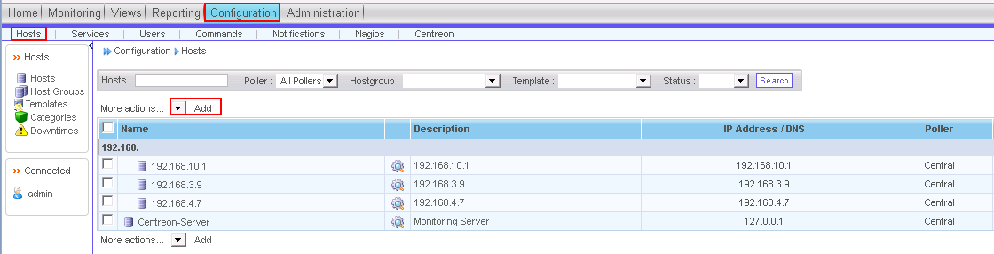

            - Click Add.
The Add a Host page is displayed.
Set the following parameters, as shown in Figure 1-1.
- Name: specifies the server host name.
- Alias: specifies the host alias.
- IP Address/DNS: specifies the server IP address.
              - Add a Host page
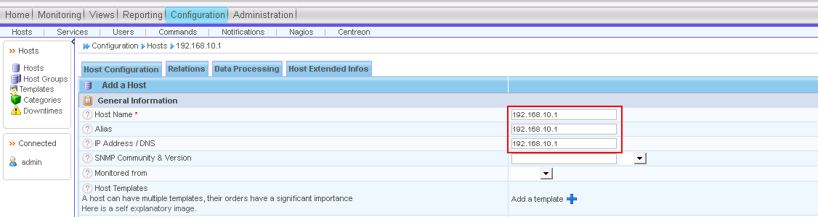

            - Click Save.
The host is configured.
----End

Creating a Service and Associating it with a Host and a Trap
            - Choose Configuration > Services.
The Services page is displayed, as shown in Figure 1-1.
              - Services page
            - Click Add. The Add a Service page is displayed.
On the Service Configuration tab, set the following parameters, as shown in Figure 1-1.
              - Add a Service page
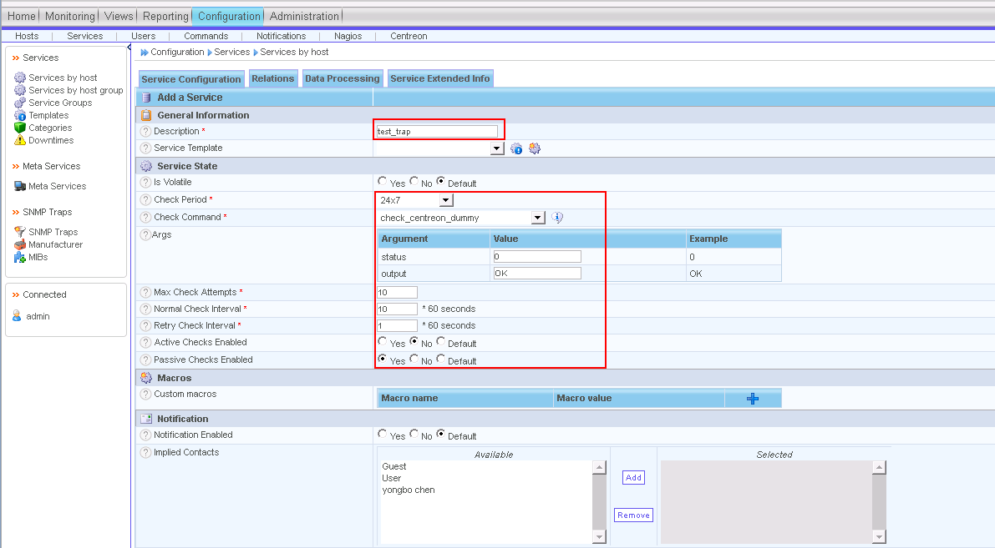
The parameters are described as follows:
- Description: specifies the name of the service to be added.
- Check Period: Select 24x7.
- Check Command: Select Check_centreon_dummy.
- Args:
- status: Enter 0.
- output: Enter OK.
- Max Check Attempts: specifies the maximum retry times.
- Normal Check Interval: specifies the regular monitoring interval.
- Retry Check Interval: specifies the interval for retrying monitoring.
- Active Checks Enabled: specifies whether to enable proactive monitoring. Set this parameter to No.
- Passive Checks Enabled: specifies whether to enable passive monitoring. Set this parameter to Yes.
            - Click the Relations tab, select the associated host from the Available list in the left area of Linked with Hosts, and click Add to add the host to the Selected list in the right area, as shown in Figure 1-1. Then click Save.
The parameters are described as follows:
- Linked with Hosts: specifies the directly connected host. You can select the host configured in 3.2.2.2 Configuring a Receiving Host.
              - Linked with Hosts area

            - Select the associated host from the Available list in the left area of Service Trap Relation, and click Add to add the host to the Selected list in the right area, as shown in Figure 1-1. Then click Save.
              - Service Trap Relation area
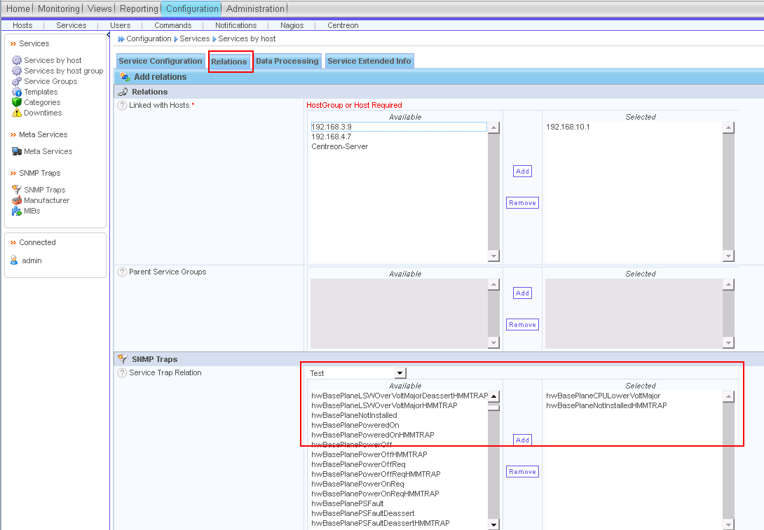

The service is configured.
----End

Generating a Configuration File and Making the ConfigurationTake Effect
            - Choose Configuration > Nagios, select all parameters in Actions, and click Export, as shown in Figure 1-1.
If Total Errors: 0 is displayed in the export results, the export is successful and the configuration takes effect.
              - Nagios page
----End

Receiving Alarms
            - Choose Monitoring > Services. Choose All Services to view the alarm information.
              - Viewing the alarm information

----End

Receiving SNMPv3 Alarms

Obtaining the Engine ID
            - In the main window of the MIB Browser tool, click .
            - In the displayed dialog box, click Edit User.
              - SNMP Protocol Preferences

            - Add an SNMPv3 user name, set Authentication protocol to HMAC-SHA and Privacy protocol to CFB-AES-128, click Change Password to change the passwords, and click OK.
              - SNMPv3 Security Parameters

            - Query the engine ID in the query results, as shown in Figure 1-1.
              - Query results

----End

Configuring the Authentication User Information
            - Use PuTTY to log in to the centreon server by using SSH.
            - Add SNMPv3 authentication information. Perform this operation only when SNMPv3 is used.
Run the following command to modify the file:
vi /etc/SNMP/SNMPtrapd.conf
Add a line of authentication configuration, as shown in Figure 1-1.
createUser –e engineId username authprotocol authpass privprotocol privpass

Passwords are displayed in plain text here, which poses security risks. For security-sensitive users, contact centreon.
              - Adding authentication information

            - Log in to centreon.
- Open the browser, enter http://centreon IP address/centreon in the address box, and press Enter.
- Enter the user name and password, and click Login.
The centreon home page is displayed, as shown in Figure 1-1.
              - Home page of centreon

            - Choose Configuration > Services, choose Manufacturer in the navigation tree, and click Add in the right pane, as shown in Figure 1-1.
              - Page for adding a Huawei vendor
            - Add a Huawei vendor and click Save, as shown in Figure 1-1.
The parameters are described as follows:
- Vendor Name: Enter Huawei.
- Alias: Enter an alias.
              - Add Vendor page

            - Install the plug-in extension package that supports Huawei servers.
- Run the following command to switch to the centreon server directory:
cd /tmp
- Run the following command to install the Huawei centreon plug-in software package:
#git clone https://github.com/serverplugin/Server_Management_Plugin_Centreon.git
- Go to the /Server_Management_Plugin_Centreon/releases directory and run the following command to decompress the Huawei centreon plug-in software package:
tar -xzvf centreonPluginForHuaweiServer_v1.0.tar.gz
            - Run the following commands to go to the directory and import the iBMC or HMM MIB file to Huawei.
- Run the following commands for a high-density/rack server:
cd /tmp/src/
perl importMib.pl -f huaweimib/bmcForCentreon.mib -m Huawei
- Run the following commands for a blade server:
cd /tmp/src/
perl importMib.pl -f huaweimib/hmmForCentreon.mib -m Huawei
            - Choose Configuration > Nagios > Snmp traps, select an available Nagios server, select all parameters in Actions, and click Generate. The trap configuration is generated, as shown in Figure 1-1.
              - Page for generating the trap configuration
----End

Configuring a Receiving Host
            - Log in to centreon.
- Open the browser, enter http://centreon IP address/centreon in the address box, and press Enter.
- Enter the user name and password, and click Login.
The centreon home page is displayed, as shown in Figure 1-1.
              - Home page of centreon

            - Choose Configuration > Hosts.
The Hosts page is displayed, as shown in Figure 1-1.
              - Hosts page

            - Click Add.
The Add a Host page is displayed.
Set the following parameters, as shown in Figure 1-1.
- Name: specifies the server host name.
- Alias: specifies the host alias.
- IP Address/DNS: specifies the server IP address.
              - Add a Host page

            - Click Save.
The host is configured.
----End

Creating a Service and Associating it with a Host and a Trap
            - Choose Configuration > Services.
The Services page is displayed, as shown in Figure 1-1.
              - Services page
            - Click Add. The Add a Service page is displayed.
On the Service Configuration tab, set the following parameters, as shown in Figure 1-1.
              - Add a Service page
The parameters are described as follows:
- Description: specifies the name of the service to be added.
- Check Period: Select 24x7.
- Check Command: Select Check_centreon_dummy.
- Args:
- status: Enter 0.
- output: Enter OK.
- Max Check Attempts: specifies the maximum retry times.
- Normal Check Interval: specifies the regular monitoring interval.
- Retry Check Interval: specifies the interval for retrying monitoring.
- Active Checks Enabled: specifies whether to enable proactive monitoring. Set this parameter to No.
- Passive Checks Enabled: specifies whether to enable passive monitoring. Set this parameter to Yes.
            - Click the Relations tab, select the associated host from the Available list in the left area of Linked with Hosts, and click Add to add the host to the Selected list in the right area, as shown in Figure 1-1. Then click Save.
The parameters are described as follows:
- Linked with Hosts: specifies the directly connected host. You can select the host configured in 3.2.2.2 Configuring a Receiving Host.
              - Linked with Hosts area

            - Select the associated host from the Available list in the left area of Service Trap Relation, and click Add to add the host to the Selected list in the right area, as shown in Figure 1-1. Then click Save.
              - Service Trap Relation area

The service is configured.
----End

Generating a Configuration File and Making the ConfigurationTake Effect
            - Choose Configuration > Nagios, select all parameters in Actions, and click Export, as shown in Figure 1-1.
If Total Errors: 0 is displayed in the export results, the export is successful and the configuration takes effect.
              - Nagios page
----End

Receiving Alarms
            - Choose Monitoring > Services. Choose All Services to view the alarm information.
              - Viewing the alarm information
----End

